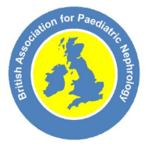

Updated COVID-19 guidance for children with kidney disease on dialysis, and immunosuppression (including kidney transplants)
Updated 6th Jan 2021

Why has the guidance been updated?
UK COVID-19 infection levels have been rising and measures remain in place to reduce the spread of COVID-19.

We have been continuing to collect information on COVID-19 cases from kidney units across the UK. Reassuringly, very few UK children with kidney disease have been admitted to hospital with COVID-19. Most infected children have been mildly affected only. There is no evidence that medicines affecting the immune system increase the risk of catching COVID-19, and no proof they cause a more severe infection. There continues to be very small numbers of cases of COVID-19 in children and young people with kidney disease with a total of 44 cases in the whole of 2020. Symptoms and outcomes are no different from those in children of a similar age without kidney disease.

We have used the latest statistics to update this information although the recent advice has not substantially changed. We will continue to follow the situation closely. Advice may change as doctors and scientists gather more evidence, and we will share all important new information with you.

Guidance produced after consultations with paediatric nephrology colleagues and kidney units. Thank you to all contributors
Yincent Tse, Lucy Plumb, Sally Hulton, Carol Inward, Dean Wallace, Jan Dudley, Martin Christian and Andrew Lunn
The risk of COVID-19 for children & young people (CYP; <18 years old), including those with kidney conditions

Please see previous versions for more background information.

This is a combination of:

- Likelihood of coming in contact with someone infected with COVID-19^{1,2}

And

- Risk of getting ill if CYP get infected with COVID-19

The information on COVID-19 continues to show that
- children are much less likely than elderly people to be severely affected by COVID-19, ³
- very few children have been admitted to hospital with COVID-19⁴ in the UK
- children and young people with kidney disease, including those who have had a kidney transplant or are on medication to control their immune system, are not at increased risk of severe infection compared to other children their age. ^{5,6,7,8}

Who should still be regarded as higher risk?
Clinically extremely vulnerable (shielded group) children and young people include those:

- With recent kidney transplants – for three months immediately after transplant

- On high level of immunosuppressive medication for active disease undergoing induction treatment: those who are currently receiving or completed treatment within 4 weeks of:
  - High dose steroids AND other very powerful immunosuppression e.g. cyclophosphamide, rituximab: though there is little evidence of increased risk
- Your kidney team determines with you that your child is at high risk

Guidance

- CYP in this group are at risk of all types of infections and complications, not only COVID-19. Families should be kept informed on how to seek urgent healthcare advice should they become unwell. It is important to be up to date with immunisations including annual inactive influenza when it is offered this year.
- Although you should try to stay at home as much as possible it is also important that CYP have time outside and exercise.⁹ When going outside you should go to quieter places where you can stay 2m away from other people.
- Parents/carers and young people within the household at work should discuss with employers about putting suitable arrangements in place to minimise risk including working from home where possible.

Children and young people waiting for a kidney transplant¹⁰

- Special protective measures and COVID-19 testing are required in the 2 weeks leading up to a planned living donor transplant to minimise the chance of infection. Your kidney unit will advise you of exact details.

- Unless they have other risk factors, CYP on the waiting list for a deceased kidney transplant are not at higher risk of catching COVID-19 or being more unwell with the infection. However, your kidney unit will decide with you, if additional measures are required before activation on the waiting list.

Frequently asked questions (F.A.Q.s)

What can we all do to minimise catching or spreading COVID-19?
- Follow the government advice for the region you are in.

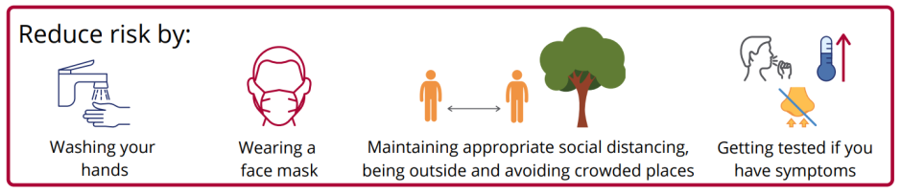

My child was previously in an intermediate risk (clinically vulnerable) group – what should they do now?
- Fortunately, the evidence now shows that this group of children is not at higher risk than other children without a kidney condition
- Families may still wish to be cautious and reduce their own risk of COVID-19 by following this simple guide What are the risks of catching COVID-19 from various activities?
- It is important to be up to date with immunisations including annual inactivated influenza vaccine.

What will happen if there is a case of COVID-19 at school?
- Do not panic. Children sent home from school because of coughing or fever are just as likely to have other common respiratory viruses. A case needs to be confirmed as COVID-19 by testing, which may take a few days.
- Government advice for what schools, parents and students need to do is here
- Any student may be asked to self-isolate for 10 days by their school or college (based on advice from their local health protection teams) if they have been in close, face-to-face contact with someone who has tested positive for the virus. An outbreak is classified as 2 or more confirmed cases within 10 days, following which the local health protection team will be sent in to advise.

What are the current recommendations for vaccination?^{11,12}
- Currently the vaccination programme is targeted at those most at risk of severe disease if infected. As children are at low risk they are not included in the first phase of vaccination. Currently the studies of the safety and effectiveness of the vaccines in those under 16 years have not yet been completed.
- Young people 16 years of age or older who are clinically extremely vulnerable (See above) will be included in step 4 of 9 in the current vaccination phase.
- Young people 16 years of age or older who have chronic kidney disease stages 3-5, are on dialysis, have a kidney transplant or have nephrotic syndrome will be included in step 6 of 9 in the current vaccination phase.
- We recommend that you attend for vaccination if you or your children are invited to do so.

Where can I get government advice?
The four different UK nations have slightly different COVID-19 healthcare and schooling advice. Advice for clinically extremely vulnerable patients (previously shielded group) is available here:
England
Scotland
Wales
Northern Ireland

References
- ONS (2020). Latest numbers of people with COVID-19
- GOV.UK (2020). Coronavirus (COVID-19) in the UK
- GOV.UK (2020). National COVID-19 surveillance reports
- RCPCH (2020). COVID-19 - service evaluation and audit on the care needs of children admitted to hospital (England)
- Plumb L, Benoy-Deeney F, Casula A, et al. COVID-19 in children with chronic kidney disease: findings from the UK renal registry. Archives of Disease in Childhood Published Online First: 24 July 2020. doi: 10.1136/archdischild-2020-319903
- Marlais M, Wlodkowski T, Vivarelli M. The severity of COVID-19 in children on immunosuppressive medication. Lancet Child Adolesc Health. 2020 doi: 10.1016/S2352-4642(20)30145-0.
- Marlais M, et al. COVID-19 in children treated with immunosuppressive medication for kidney disease. Arch Dis Child 2020;0:1–4. doi:10.1136/archdischild-2020-320616
- Mastrangelo et al, Impact of COVID-19 Pandemic in Children with CKD or Immunsuppression. CJASN December 2020, CJN.13120820; DOI: https://doi.org/10.2215/CJN.13120820
- RCPCH (2020) COVID-19 summaries on key findings on children and young people’s views.
- NICE (2020). COVID 19 rapid guideline: renal transplantation [NG178]
- Joint Committee on Vaccination and Immunisation https://www.gov.uk/government/publications/priority-groups-for-coronavirus-covid-19-vaccination-advice-from-the-jcvi-30-december-2020/joint-committee-on-vaccination-and-immunisation-advice-on-priority-groups-for-covid-19-vaccination-30-december-2020#fn:3
- Green Book Chapter 14a https://www.gov.uk/government/publications/covid-19-the-green-book-chapter-14a

