Causes of AKI

Pre-Renal AKI - decreased perfusion of the kidneys:-

- Volume depletion (excessive diuresis, haemorrhage, shock, burns, severe trauma)
- Cardiovascular disorders (congestive cardiac failure & acute MI)
- Obstruction of renal arteries (renal thrombosis, renal artery stenosis)

Post-Renal AKI - obstruction to urine outflow, from the collecting ducts in the kidney down to the urethra.

- Deposition of crystals in the tubules, eg. uric acid, sulphonamides, aciclovir, cisplatin.
- Renal stones in the ureter or bladder

- Tumour, either within the tract or pressing on it from another pelvic organ, eg. prostate hypertrophy, bladder cancer, bowel cancer.
Intra-Renal AKI – damage to the kidney itself
- Sustained hypoperfusion, or exposure to nephrotoxic agents
Antibiotics - aminoglycosides, amphotericin. Analgesics - paracetamol, salicylates Ethylene glycol (antifreeze)

- Autoimmune renal disease - vasculitis, SLE, interstitial nephritis, glomerulonephritis, etc

Contact the RPG Secretariat at:-
UK Renal Pharmacy Group

Renal Association,

Brandon House, Building 2001

Southmead, Bristol

BS34 7RR, UK.

Tel: 01117 4148152.

e-mail: RPG@renal.org

www.renalpharmacy.org.uk

High Risk Medicines and Actions

When a patient is admitted with AKI, a thorough review of medication is required:

- To eliminate potential causes / risk / contributory factors for AKI
- To avoid inappropriate combinations of medicines in the context of AKI
- To ensure all prescribed medicines are clinically appropriate
Review all Medications

- Remember to check medication history thoroughly and ask about “Over the Counter” preparations, herbal remedies or teas and alternative therapies.

- Check use of recreational drugs (cocaine, ketamine, etc).
- Consider withholding nephrotoxic medications on admission in patients at high risk of AKI
- Ensure that all doses are amended concomitant with the patient’s degree of renal impairment. Re-assess daily until AKI resolves

- Educate the patient before discharge re which medications to restart and when.
- Discuss medicines to avoid in future and “sick day” guidance.
- Ensure information on which medications to restart and when are communicated to the GP or next care setting.
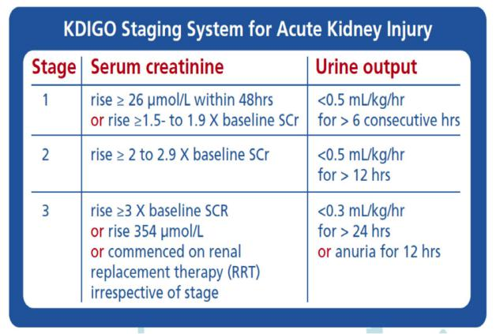

Acute Kidney Injury (AKI) Medicines Optimisation

UK Re AKI is a rapid deterioration in a patient’s renal function over hours or days secondary to an acute event.

- 65% of AKI starts in community
- In the hospital setting 20% of acute admissions will develop AKI.

- Up to 30% of all cases of AKI are thought to be due to drugs.

- 5% of inpatients develop drug-induced renal impairment.

Comprehensive guidelines on medicines management and care bundles in patients with AKI can be found at:

www.thinkkidneys.nhs.uk/aki

 | Effects on renal/fluid/electrolyte | Change in the side effect profile when renal | Action in presence of AKI
 | physiology | function is reduced
NSAIDs / COX II inhibitors | Altered haemodynamics within the kidney leading |  | Avoid these agents in people at high risk of AKI
 | to underperfusion and reduced glomerular
 | filtration
Opioid analgesics |  | Accumulation of active metabolites in AKI (especially | Avoid long acting preparations.
 |  | morphine, pethidine and codeine) – increased | Reduce dose and frequency
 |  | incidence of CNS side effects & respiratory depression | Use opiates with minimal renal excretion e.g. fentanyl,
 |  |  | oxycodone, hydromorphone, tramadol
Pregabalin & Gabapentin |  | Accumulation leading to an increase in CNS side | Reduce dose
 |  | effects
Antihypertensives (Ca-channel blockers, | Hypotension may exacerbate renal hypo-perfusion | Risk of bradycardia with Beta Blockers | Consider withholding / reduce dose depending on blood
a-blockers, b-blockers, etc) |  |  | pressure
ACEI / ARBs / Aliskiren | Hypotension |  | In some situations, e.g. heart failure continuing them
 | Hyperkalaemia |  | might actually be helpful
 |  |  | In AKI consider with holding
Diuretics (Thiazide & Loop) | Volume depletion | Loop diuretics preferred as thiazides less effective if | If volume depleted, consider with holding
 | Acute interstitial nephritis (rare) | GFR < 25ml/min. However thiazides can potentiate
 |  | the effects of loop diuretics
Potassium sparing diuretics amiloride, | Volume depletion |  | Stop if AKI
eplerenone spironolactone | Hyperkalaemia
Statins | May cause AKI if rhabdomyolysis is present | Increased risk of rhabdomyolysis | Stop if AKI due to rhabdomyolysis, OR if patient develops
 |  |  | unexplained / persistent muscle pain
Digoxin | Hyperkalaemia | May accumulate in AKI leading to bradycardia, visual | Reduce dose
 |  | disturbances, mental confusion | Monitor potassium and drug levels
Direct Oral Anticoagulants |  | May accumulate leading to increased risk of bleeding | Consider withholding, particularly agents with high renal
 |  |  | clearance.
Aciclovir / Valaciclovir | Crystal nephropathy | Drug accumulates in reduced renal function leading to | Reduce dose
 | Acute interstitial nephritis (rare) | mental confusion, seizures | Encourage patient to drink plenty
Aminoglycosides | Tubular cell toxicity | Ototoxicity | Avoid if possible. If use is unavoidable, reduce dose &/or
 |  |  | increase dosing interval. Monitor drug levels and renal
 |  |  | function 2 – 3 times per week
Carbapenems |  | Drug accumulates in reduced renal function leading to | Reduce dosing frequency
 |  | mental confusion, seizures
Fluconazole |  | Accumulation leading to acute mental confusion, | Reduce dose
 |  | coma, seizures
Ganciclovir / Valganciclovir | Crystal nephropathy | Accumulation leading to neutropenia, anaemia and | Reduce dose
 |  | thrombocytopenia | Monitor renal function and full blood count
Vancomycin | Acute interstitial nephritis (rare) | Accumulation leading to renal toxicity, ototoxicity | Reduce dose / increase dose interval
 |  |  | Monitor levels
Trimethoprim | Increased risk of hyperkalaemia (especially in | Accumulation increases risk of hyperkalaemia | Avoid or reduce dose (particularly if patient is already
Co-trimoxazole | combination with spironolactone or ACEI/ARB) | (particularly with high doses), nausea and vomiting | taking an ACEI, ARB or spironolactone)
Phenytoin | Acute interstitial nephritis (rare) | Risk of phenytoin toxicity if patient has low serum | Monitor levels. Correct phenytoin levels for uraemia and
 |  | albumin levels | low serum albumin
Hypoglycaemic Drugs |  | Accumulation in AKI may increase risk of | Avoid long acting preparations
 |  | hypoglycaemia | Monitor blood glucose levels & reduce dose if necessary
Metformin |  | Risk of lactic acidosis increased | Avoid if GFR < 30 ml/min
 |  | Accumulation leading to hypoglycaemia

