Continuous Ambulatory Peritoneal Dialysis
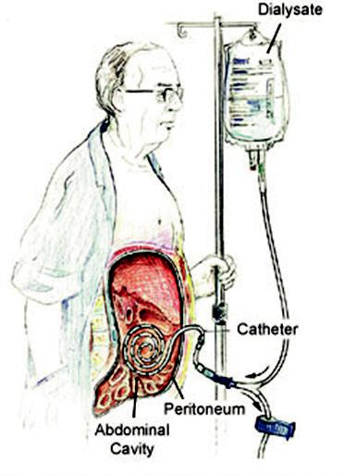

Peritoneal dialysis uses the peritoneum in a person's abdomen as the membrane through which fluid and dissolved substances are exchanged with the blood. Benefits over haemodialysis include greater flexibility and better tolerability in those with significant heart disease. The dialysate fluid that is instilled into the abdominal cavity typically contains sodium chloride, lactate or bicarbonate and a high percentage of glucose to ensure hyperosmolarity. The amount of dialysis that occurs depends on the volume of the dwell, the regularity of the exchange and the concentration of the fluid. CAPD typically involves 4 manual exchanges a day, each of 2 litres of PD fluid.

Complications may include peritonitis, hernias, high blood sugar levels, constipation, bleeding in the abdomen, and blockage of the catheter. PD is not possible in those with significant prior abdominal surgery or inflammatory bowel disease.

Automated Peritoneal Dialysis
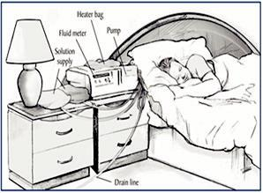

For APD the patient dialyses overnight for 5-7 days each week, with APD cycles of between 3 and 10 dwells per night, using 15-20 litres of dialysis fluid. APD may have psychosocial advantages for younger patients and those who are employed or pursuing an education.

Continuous Renal Replacement Therapy

Continuous Haemofiltration (CVVH)
Blood passed under pressure down one side of a highly permeable membrane Water and solutes are removed by convection, driven by the pressure gradient.

Continuous Haemodiafiltration (CVVHD) Blood is passed along one side of a semi-permeable membrane. Crystalloid solution is pumped along other side of membrane in opposite direction. Solutes move across membrane by convection

- diffusion at rate depending on concentration gradient & molecular size.
● Can be done anywhere as no specialist plumbing required
● Much less aggressive than haemodialysis

Better for haemodynamically unstable patients.
● Usually employed in the acute situation, eg in the management of AKI on ICU

- Handy Guide to Dialysis

UK R

Dialysis is an imperfect treatment to replace kidney function because it does not correct the compromised endocrine functions of the kidney. Dialysis treatments replace some of the functions through diffusion (waste removal) and ultrafiltration (fluid removal).

Contact the RPG Secretariat at:-
UK Renal Pharmacy Group

Renal Association,

Brandon House, Building 2001

Southmead, Bristol

BS34 7RR, UK.

Tel: 01117 4148152.

e-mail: RPG@renal.org

www.renalpharmacy.org.uk

Types of Dialysis

- Intermittent Haemodialysis / Haemodiafiltration

- Continuous Haemofiltration / Haemodiafiltration

- Continuous Ambulatory Peritoneal Dialysis

- Automated Peritoneal Dialysis
- Slow Low Efficiency Dialysis / SLED-f

Intermittent Haemodialysis

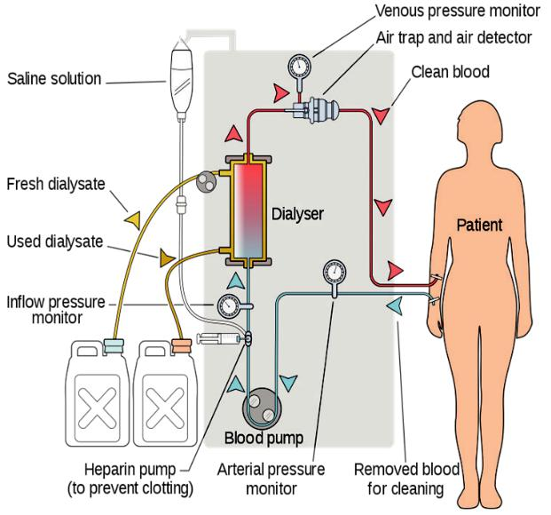

Conventional haemodialysis is usually done three times per week, for about 3–5 hours for each treatment. Blood is passed along one side of a semi-permeable membrane. Crystalloid solution is pumped along the other side of the membrane in the opposite direction. Solutes move across the membrane by convection & diffusion at rates depending on the concentration gradient and molecular size. During dialysis, the patient's blood is drawn out through a dialysis catheter at a rate of 200–400 mL/min. The blood is then pumped through the dialysis filter, and after processing, is pumped back into the patient's bloodstream. During the treatment, the patient's entire blood volume (about 5 litres) circulates through the machine every 15 minutes.

The dialyser, or artificial kidney, is a cylindrical bundle of hollow fibres, whose walls are composed of semi-permeable membrane, these fibres are anchored into a clear plastic cylindrical shell. The blood port at each end of the cylinder communicates with each end of the bundle of hollow fibres. This forms the "blood compartment" of the dialyser. The space around the hollow fibres is the "dialysate compartment." Blood is pumped through this bundle of very thin capillary-like tubes, and the dialysate is pumped through the space surrounding the fibres. Pressure gradients are applied to move fluid from the blood to the dialysate compartment.

Injection ports on the venous return side of the dialysis circuit allow for the administration of intravenous drugs during dialysis.

Dialysis Access
Two primary methods are used to gain access to the blood for haemodialysis: an intravenous catheter, and an arteriovenous fistula

AV Fistula
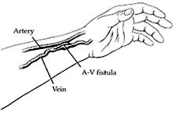

A vein in the arm is surgically attached to an artery. Both the artery and the vein dilate and elongate in response to the greater blood flow, but the vein dilates more and becomes "arterialised". When the vein is large enough to allow cannulation, the fistula is defined as "mature".

Central Venous Catheters

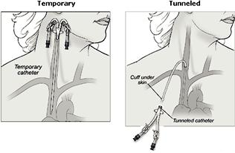

- Usually inserted into jugular vein or femoral vein
- Temporary lines limited duration (< 2 weeks)

- Permanent lines are usually cuffed and tunnelled
- Complications include infection / clotting – a ‘line lock’ is used between sessions

Drug removal during dialysis
This can be affected by:

- The properties of the medication

- The type of dialysis membrane – i.e. is it a high flux or low flux membrane?
- The Renal Drug Database provides information on drug removal by different types of dialysis https://renaldrugdatabase.com/

SLED / SLED-f
This is essentially haemodialysis, but with low blood and dialysate pump speeds and a longer duration, usually 6-8 hours each day.
Using predilution SLED-f may reduce the risk of the filter clotting. Drug removal can be as good as via CVVHDF during the procedure.

