Medication Do’s & Don’ts

- AVOID
- Live vaccines o NSAID’s
o Macrolides/Azole antifungals

- CAUTION
o Cyp3A4 inducers/inhibitors e.g. carbamazepine, phenytoin, rifampicin (significant interactions)

o Antibiotics

- Herbal products o Statins
o Different tacrolimus/ciclosporin brands o Pregnancy
o ACEI/ARB’s (monitor GFR)

What to consider in transplant patients admitted to non-Tx centre
- Ensure correct immunosuppression is prescribed – brand prescribed tac/CyA
- Check patients renal function

- Ensure new meds prescribed are correct doses for patient’s level of renal function
- Average GFR 30ml/min, range 25-50ml/min

- Appropriate TDM

- Beware drug-drug interactions

Contact the RPG Secretariat at:-
UK Renal Pharmacy Group

Renal Association,

Brandon House, Building 2001

Southmead, Bristol

BS34 7RR, UK.

Tel: 01117 4148152.

e-mail: RPG@renal.org

Renal Transplantation

- Transplantation is a form of Renal

Replacement Therapy (RRT).

- There are approximately 20,000 renal transplant recipients in the UK
- £1-1.5B per annum spent on renal failure (3% of NHS budget)
- Transplant patient costs £46K over 5 years

- Dialysis patient costs £175K over 5 years

- 23 adult renal transplant centres in the UK

(19 in England)

- Non-transplant centres follow-up 25% of recipients

Who is a candidate for renal transplant?

- All CKD 5 patients fit for major surgery and for chronic immunosuppression.
- All patients predicted to have an increased life expectancy post-transplantation
- Placement on the transplant waiting list will be limited by individual co-morbidity and prognosis.

- Age is not a contra-indication to transplantation but age related co-morbidity is an important limiting factor.

Benefits of renal transplant

- Freedom to travel, eat, drink, work, play

- Fertility

- Improved Quality of Life

- Improved survival

- Near normal lifestyle

- Cost benefit to NHS

Donor Register
The NHS Organ Donor Register is a confidential list of people who want to donate their organs and/or tissue. When you die, your organs could help someone else to live.

https://www.organdonation.nhs.uk/

Medicines Optimisation in Renal Transplantation

UK Re
A kidney transplant is a surgical procedure in which a healthy kidney from one person is placed into another whose kidneys have stopped working.
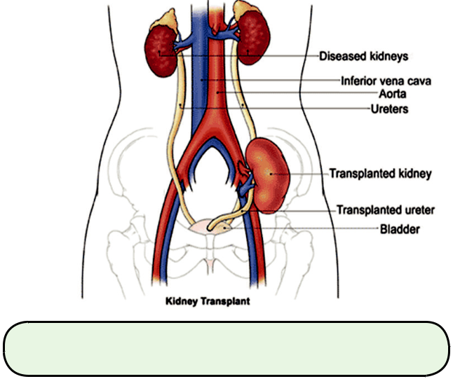

www.renalpharmacy.org.uk

What is Rejection?

- The body sees a kidney transplant as foreign and attacks it to get rid of it.

- This is a normal response of the body’s immune system.

- Rejection may be prevented by medication, but the possibility of rejection never goes away. The body will not adapt to the kidney, nor will the kidney change to accommodate the body.

- Rejection is less of a problem after the first

3-6 months providing medication is taken consistently

Strategies to prevent rejection

2 mechanisms:-

- Suppress immune system with medication

- Reduce chances of immune cascade being triggered at the time of transplant

o ABO blood group compatibility o Cross match to rule out recipient

antibodies

o HLA matching

Immunosuppressive Medications

- Induction antibody o Alemtuzumab
o Basiliximab

o Anti-thymocyte immunoglobulin

(Thymoglobuline® )

o + intra-operative Methylprednisolone

- Oral immunosuppressants o Calcineurin Inhibitors (CNIs)
(Tacrolimus/Ciclosporin)

+

o Antiproliferative agents

(Mycophenolate/Azathioprine)

+

o Prednisolone

o MToRs (Sirolimus)

- See NICE guidance TA481 (www.nice.org.uk)

Generic Immunosuppression

- Tacrolimus/Ciclosporin are critical dose drugs

- Must be prescribed by specific brand

● Ciclosporin (Neoral)

o Generic versions include Deximune, Capsorin, Capimune, Vanquoral

● Tacrolimus immediate release (Prograf)

o Generic versions include Adoport, Capexion, Tacni & Vivadex

- Tacrolimus prolonged release (Advagraf, Envarsus)
- There is no requirement for mycophenolate (either mycophenolate mofetil or sodium) or azathioprine to be prescribed by brand as they are not critical dose drugs.

Adjunctive Therapy

- Aspirin

- Cotrimoxazole (if allergic, then dapsone or monthly nebulised pentamidine)
- Ranitidine or PPI

- Valganciclovir/Valaciclovir for CMV prophylaxis

- Isoniazid (+ pyridoxine ) Latent TB infection prophylaxis if at high risk of TB Antihypertensives

- Cholesterol lowering drugs (atorvastatin preferred)
- Lamivudine for Hepatitis B prophylaxis

Long term Challenges

- We are successful in preventing Acute

Rejection

- Chronic Allograft Nephropathy (CAN) (chronic rejection) is now the major challenge.

- Use of CNI’s, early acute rejection, CMV infection, BKV infection and non-adherence have all been implicated

- Try switching from CNI to Sirolimus

- Acute Antibody Mediated Rejection is also a significant challenge – managed with plasma exchange, IVIg, Rituximab, etc.

Drawbacks to Transplantation

- Adverse effects of immunosuppressant medications

- Increased infection risk

  - UTIs, CMV, PCP, fungal

- Increased neoplasia risk

  - Post Transplant Lymphoproliferative Disorder (PTLD)
■ Rare

■ Associated with cumulative immunosuppression ‘load’
■ Can occur any time after transplantation

- Increased risk of cervical cancer

- Increased risk of skin malignancies

■ Elderly

■ Long term immunosuppression, especially the antiproliferative agents

Co-Morbidities

- Years of disease, renal failure, diet, drugs
      - Cardiovascular issues
  - Hypertension

  - Hyperlipidaemia

  - New onset diabetes after transplantation

- Bones

o Osteodystrophy + steroids

  - Bisphosphonates

- Cosmetic issues o Concordance
  - Ciclosporin – hirsutism, acne gum hypertrophy
  - Tacrolimus – alopecia

  - Sirolimus - acne

